ECE 3331

Introduction to Signal Processing

Laboratory Project

Instructor: Ilia G. Polushin

Ziqin Shang

250890594

1. **Low-Pass**

For the low pass filter, the cutoff frequency is 190-94/2 = 143Hz, and the allowance frequency for the low pass filter is 50Hz, by converting the hertz to rad/s, the cutoff frequency is , and the allowance frequency is . which are the locations of poles and zeros of the low pass filter’s transfer function. For a lowpass filter, the lower frequency must be emphasized, and the higher frequency must be de-emphasized. As demonstrated in the pole-zero plot, the poles are corresponded to , and the zeros are corresponded to .

Figure 1. Magnitude Response of Lowpass Filter

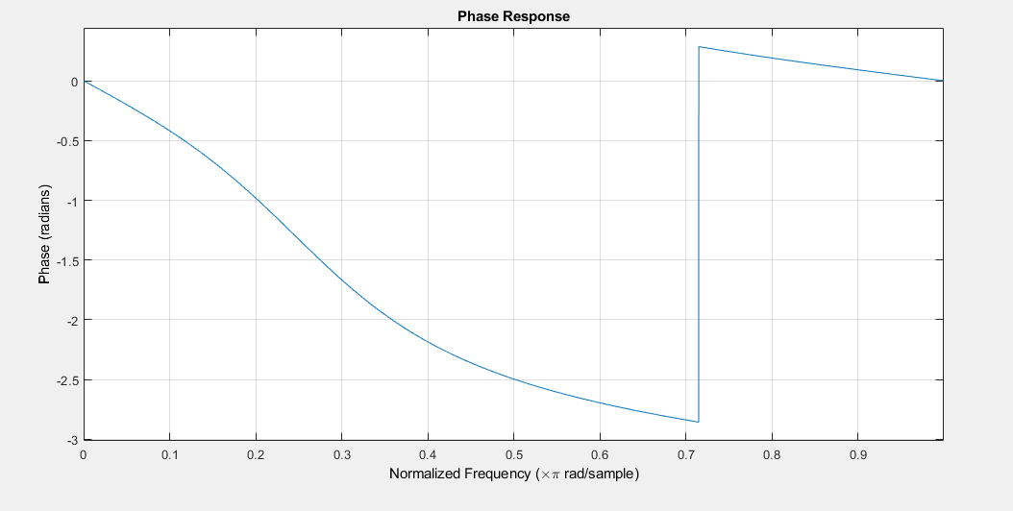

Figure 2. Phase Response of Lowpass Filter

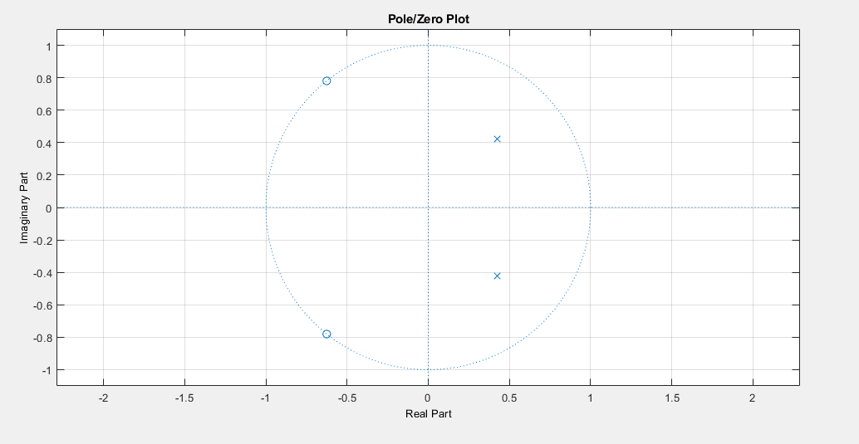

Figure 3. Poles and Zeroes on the Unit Circle Plot of Lowpass Filter

As demonstrated above, the designed filter is able to allow frequencies less than 0.25πrad/s to pass the filter and deny frequencies more than 0.715πrad/s. The poles were placed in 0.25πrad/s and zeros were placed in 0.715πrad/s. Additionally, by setting r to 0.6, the poles are observed to lie within the circle rather than on the perimeter, which means that the stability of the system is guaranteed.

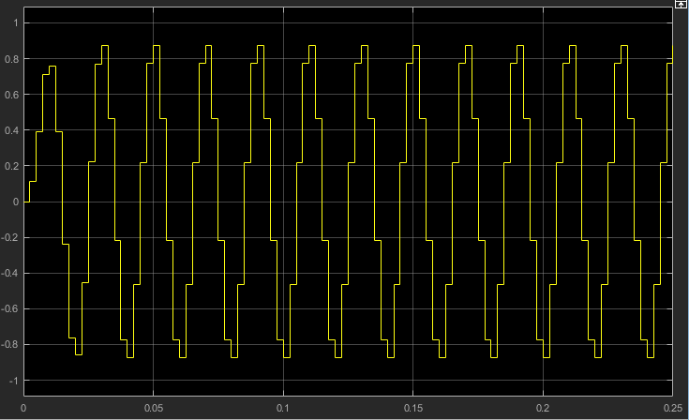

Figure 4. Lowpass Filter output with 50 Hz Sine Waveform input

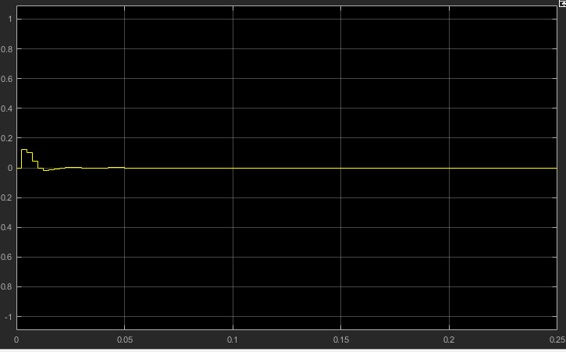

Figure 5. Lowpass Filter output with 143 Hz Sine Waveform input

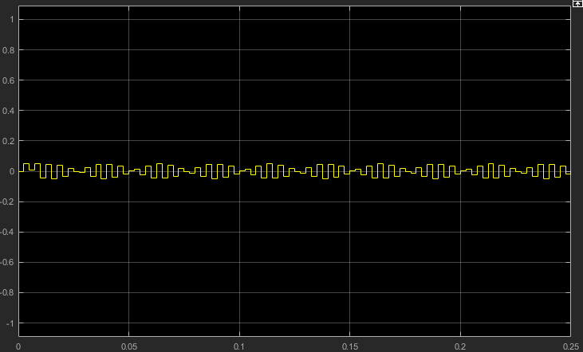

Figure 6. Lowpass Filter output with 180 Hz Sine Waveform input

As observed from Simulink results, the filter did not affect the signals with lower frequency(50Hz), as a result, the output is identical with the input. At the cutoff frequency(143Hz), the input signal was filtered out, and at higher frequency(180Hz) the signal were still filtered out, but with some residual amount of signals not filtered out, this is because the magnitude of the response is non-zero, but the amplitude decreased significantly. Considering the results demonstrated above, the designed low-pass filter is effective. 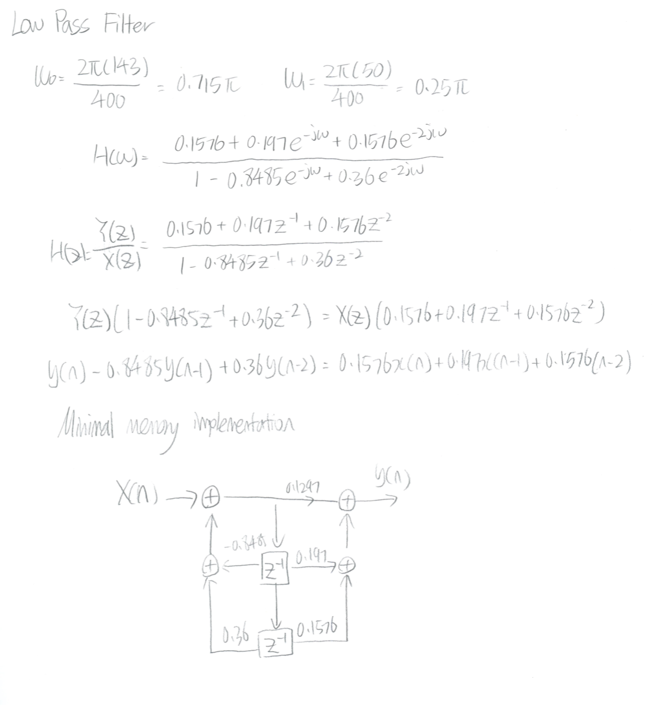

Calculations

Impulse Response

Solving for A

1. **High-Pass**

For the high pass filter, the cutoff frequency is 190-94/2 = 143Hz, and the allowance frequency for the high pass filter is 50Hz, by converting the hertz to rad/s, the cutoff frequency is , and the allowance frequency is . which are the locations of poles and zeros of the high pass filter’s transfer function. For a high-pass filter, as a contrast to the low-pass filter, the higher frequency must be emphasized, and the lower frequency must be de-emphasized. As demonstrated in the pole-zero plot, the poles are corresponded to , and the zeros are corresponded to .

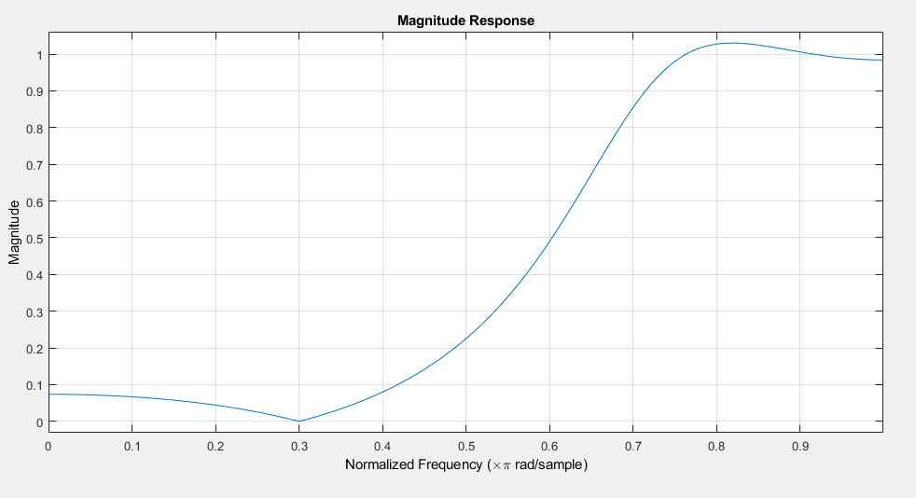

Figure 7. Magnitude Response of High-pass Filter

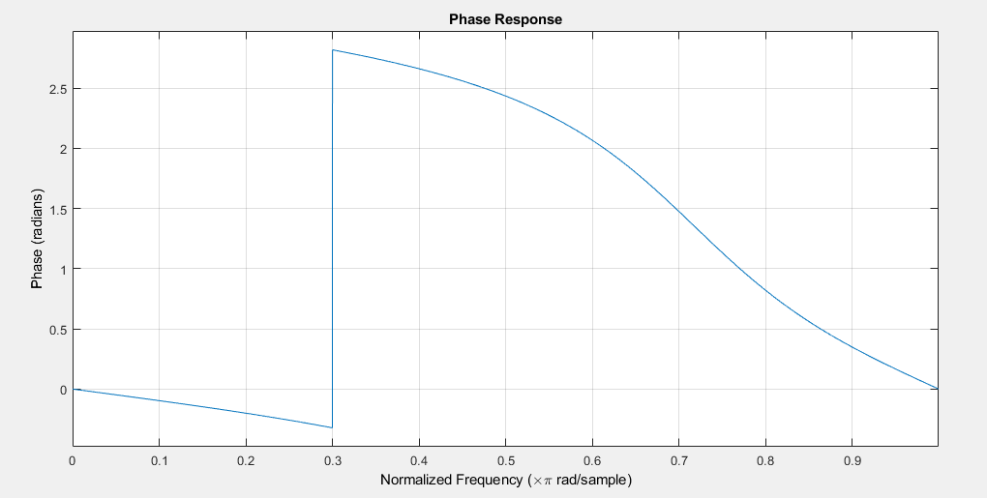

Figure 8. Phase Response of High-pass Filter

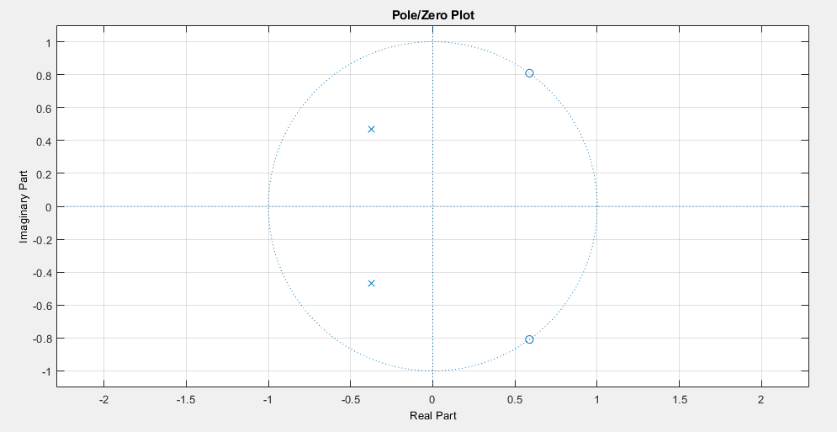

Figure 9. Phase Response of High-pass Filter

As demonstrated above, the designed filter is able to allow frequencies more than 0.715πrad/s to pass the filter and deny frequencies less than 0.3πrad/s. The poles were placed in 0.3πrad/s and zeros were placed in 0.715πrad/s. Additionally, by setting r to 0.6, the poles are observed to lie within the circle rather than on the perimeter, and the graph is reversed comparing with the low-pass pole-zero plot, which means that the stability of the system is guaranteed.

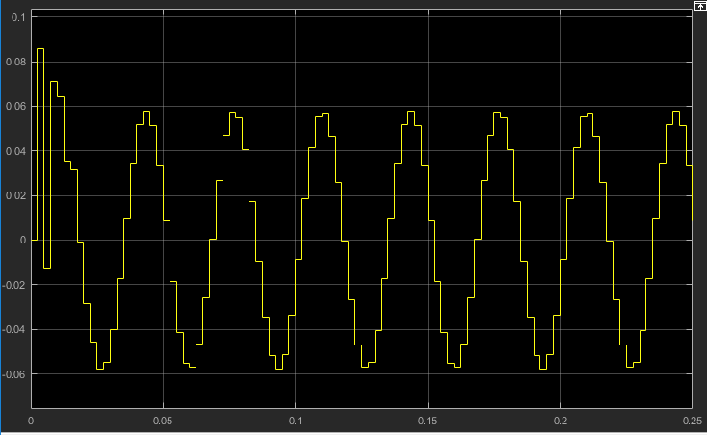

Figure 10. High-pass Filter output with 30 Hz Sine Waveform input

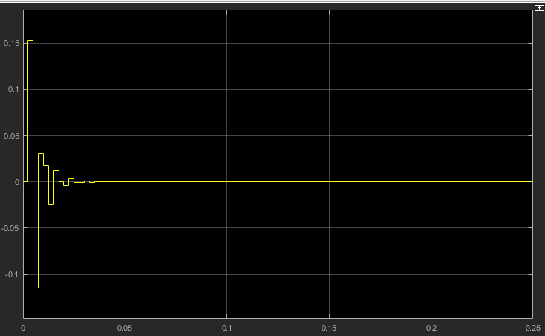

Figure 11. High-pass Filter output with 60 Hz Sine Waveform input

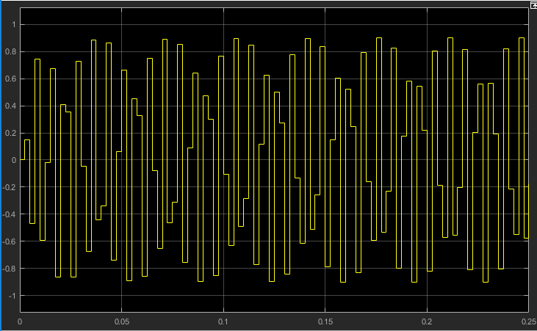

Figure 12. High-pass Filter output with 143 Hz Sine Waveform input

As observed from Simulink results, the filter did not affect the signals with higher frequency(143Hz), as a result, the output is identical with the input. At the cutoff frequency(60Hz), the input signal was filtered out, and at lower frequency(30Hz) the signal were still filtered out, but with some residual amount of signals not filtered out, this is because the magnitude of the response is non-zero, but the amplitude decreased significantly. Considering the results demonstrated above, the high-pass filter is effective. 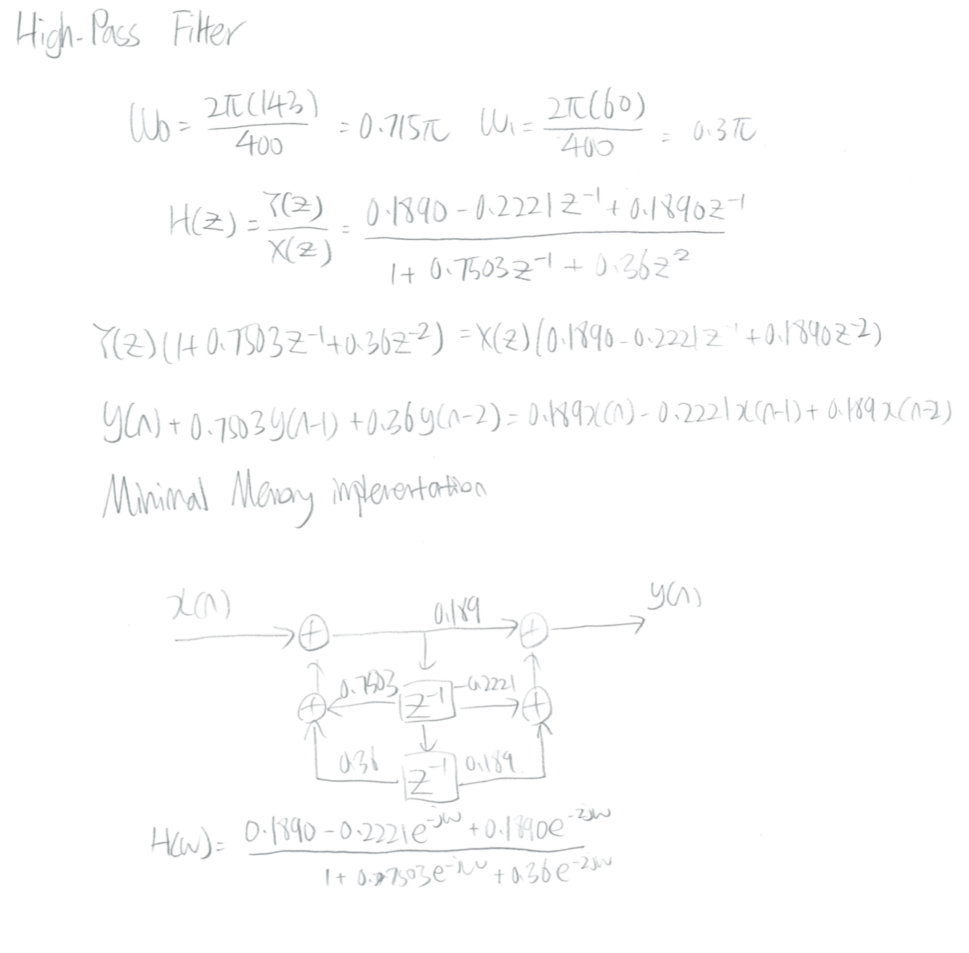

Calculations

Impulse Response

Solving for A

1. **Notch Filter**

For the notch filter, it is required to remove the frequency at 144Hz, by converting the hertz to rad/s, the removed frequency is , to remove this specific frequency, a pole and zero must be placed very close to each other.

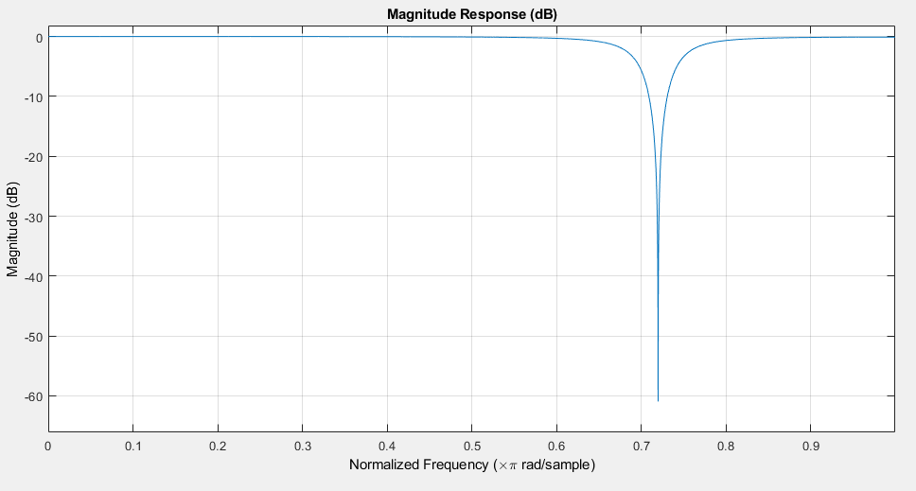

Figure 13. Magnitude Response of Notch Filter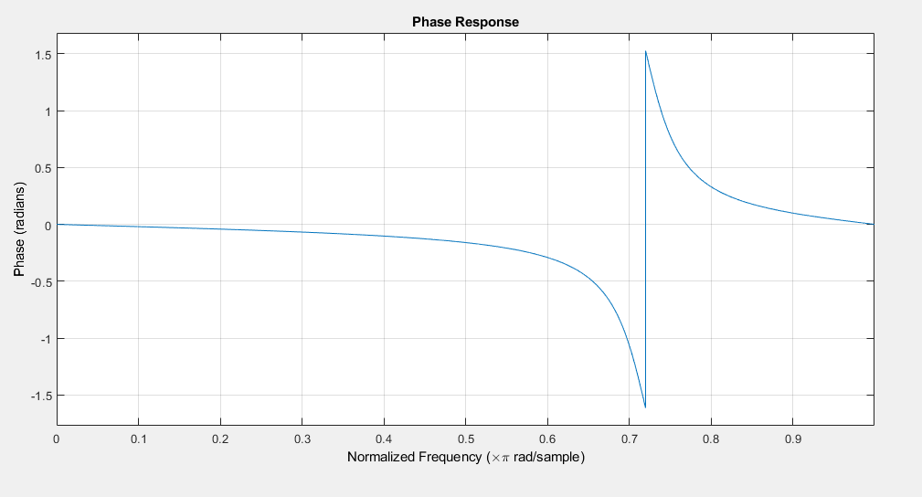

Figure 14. Magnitude Response of Notch Filter

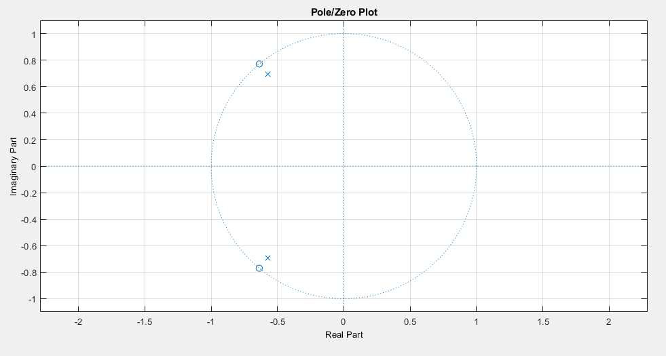

Figure 15. Pole-Zero plot of High-pass Filter

As demonstrated above, the magnitude response and phase response correspond to the removed frequency 0.72πrad/s, the magnitude plot experienced a significant drop at 0.72πrad/s, and phase response shifted at 0.72πrad/s. 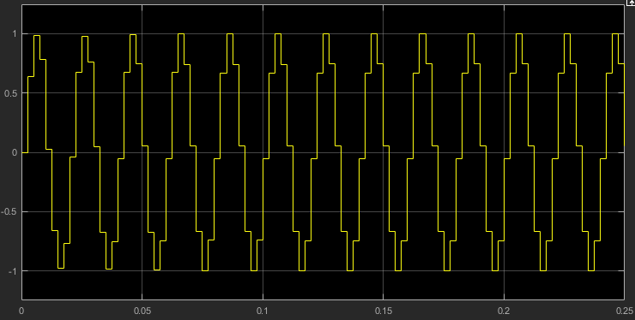

Figure 16. Notch Filter output with 50 Hz Sine Waveform input

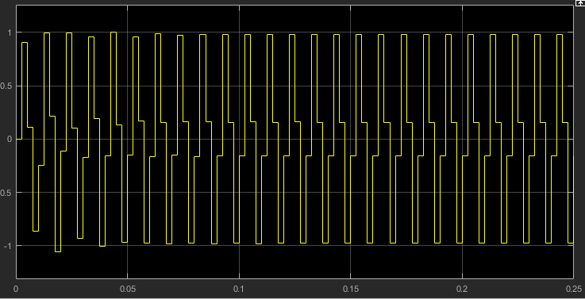

Figure 17. Notch Filter output with 100 Hz Sine Waveform input

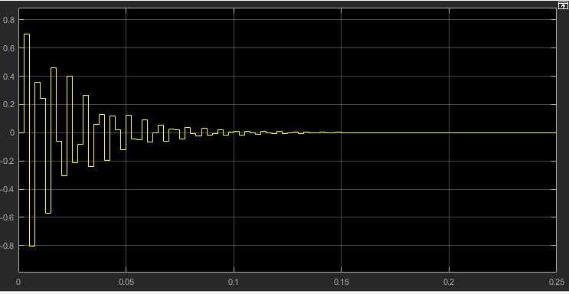

Figure 17. Notch Filter output with 144 Hz Sine Waveform input

As observed from Simulink results, the filter did not affect the signals other than removed frequency. At removed frequency(144Hz), the signal filtered and eliminated as seen in figure 17, which implies that the designed notch filter is effective.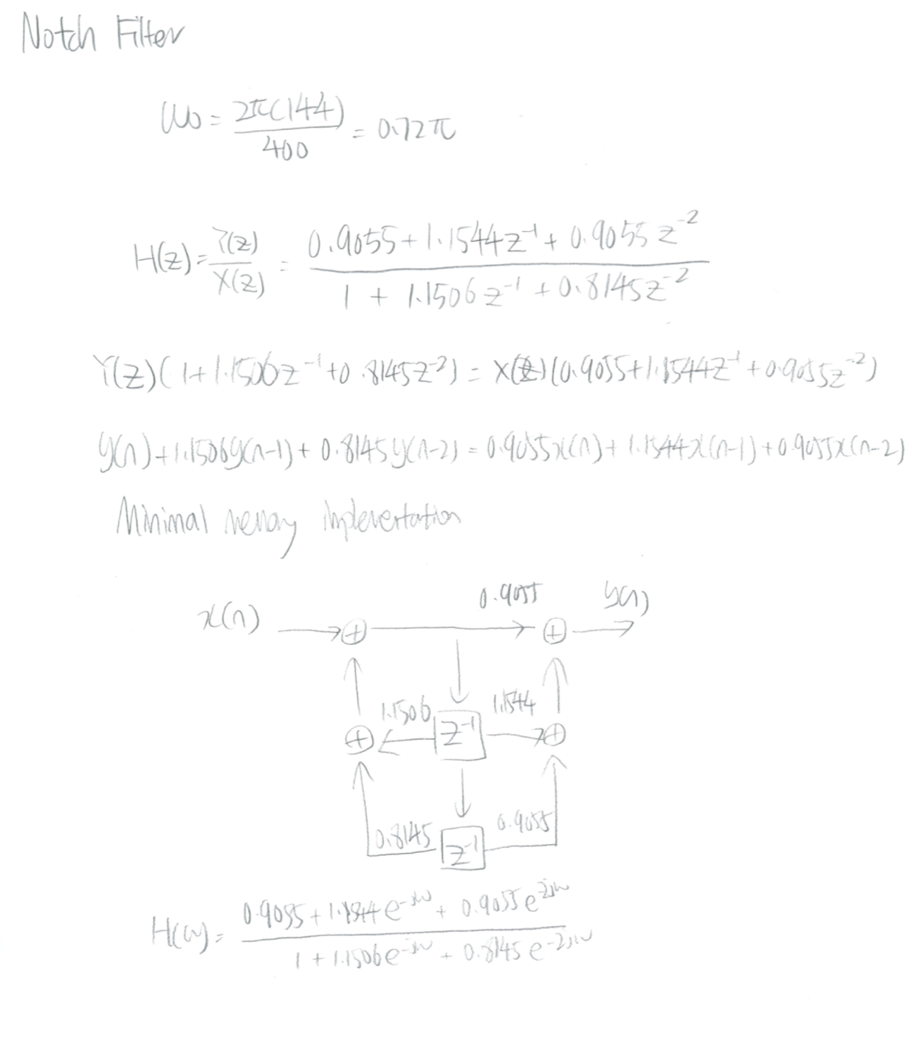

Calculations

Impulse Response

Solving for A

Appendix A. Executed Code

